Home Security System
Prepared by: Frankie Klimek, Landon Meimerstorf, Kameron Jackson
April 28, 2026
CSEC 3223-001
Dr. Abdul Razaque
Project Summary & Purpose
- Our Home Security System monitors for security events and detects unauthorized inputs and access to features of a virtual home. All components of the system are designed to simulate different aspects of a home, such as a door lock, doorbell, doorknob, alarm system, and panic button. Each of these components is controlled by Raspberry Pi GPIO and an Arduino which will expanded upon later in this document.
- The purpose of this project is to simulate a home security system using open-source software and small computing modules, as well as the development process for these kinds of systems. It also helped us understand underlying engineering of electronics and how different electronics can work together to produce a strong product.
Design & Components
- This home security system contains the following components:
- 1 x Raspberry Pi 4
- 1 x Arduino Uno R3
- 1 x Serial USB Cable
- 1 x GPIO Extension Cable
- 1 x Breadboard
- 1 x 1602IIC LCD Module
- 1 x 16-character Keypad (4x4)
- 1 x HW-416 Infrared Motion Sensor
- 1 x Servo Motor
- 1 x Common Anode RGB LED
- 1 x Regular LED
- 1 x Active Buzzer
- 2 x Push Button
- 3 x 220Ω Resistor
- 33 x Jumper cables
- Design details:
- Raspberry Pi acts as the central controller for entire system.
- Arduino used for keypad input only. Runs C++ code to detect different keys and can discern between different keys.
- Arduino connected to Raspberry Pi via USB. Pi pulls the keypad input via a serial connection which offloads the functionality from the Pi, freeing up a considerable number of GPIO pins.
- Raspberry Pi connects directly to breadboard via GPIO Extension Cable.
- Many GPIO pins are connected to components attached to the breadboard, as well as powered by the 3.3V or 5V pins of the IO header.
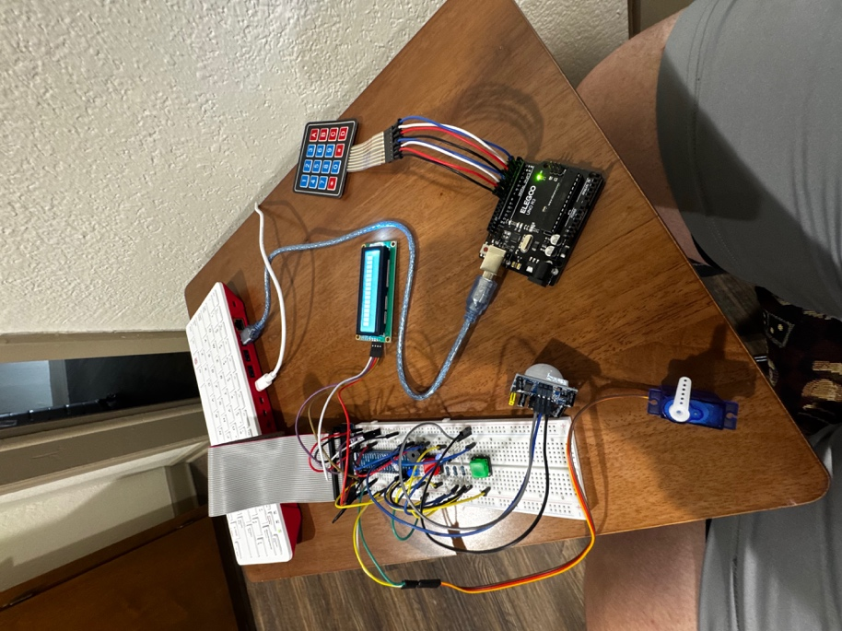
System Operation
- Several python files were used in the process of developing this system. Each component of the system is broken up into its own python script using object-oriented programming. By doing so, we were then able to create one root file that calls on the source files of each component, eliminating complexity from one single script.
- Arduino handles the keypad input with C++ programming.
- Arduino sends keypad input to Pi via serial connection.
- Pi connects to breadboard via GPIO extension cable.
- Each component connects from the GPIO extension:
  - Red push button acts as doorknob for the system
  - Green push button acts as the panic switch
  - Servo acts as a hinge-style door lock
  - 16x2 LCD displays system information, such as armed, disarmed, door open, panic message, wrong code attempts, etc.
  - RGB LED illuminates green or red based on successful or unsuccessful keypad entries, as well as if the panic switch is activated.
  - The buzzer activates on the panic switch, forced entry, and on the doorbell ring.
  - The Infrared sensor controls a separate single-color LED to act as motion detected lighting.
- All components work together to form a cohesive security system.

